RESNET, BILSTM, MULTIHEAD ATTENTION

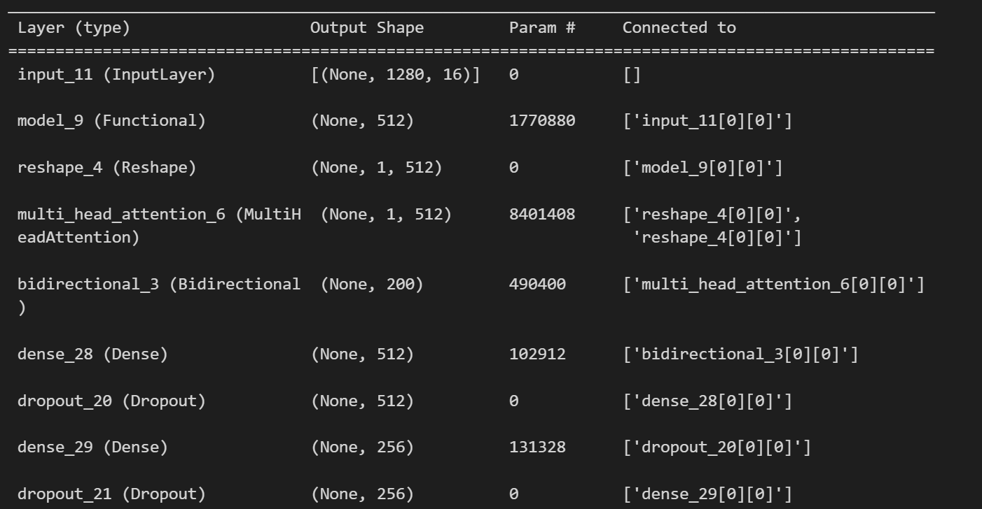

Test Loss: 0.08041903376579285

Test Accuracy: 0.9941860437393188

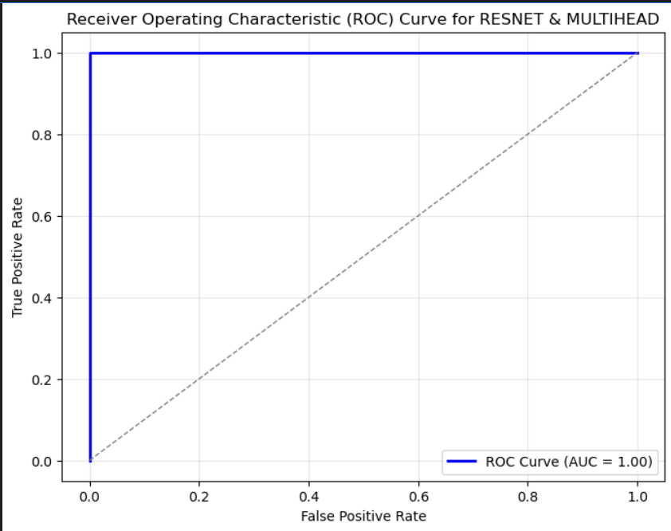

RESNET, BILSTM, TRANSFORMER

Test Loss: 0.05834939330816269

AUTO ENCODER DECODER BASED CLASSIFIER

Test Loss: 0.7905187606811523

Test Accuracy: 0.5348837375640869

